Mice
By EmKatCrochet

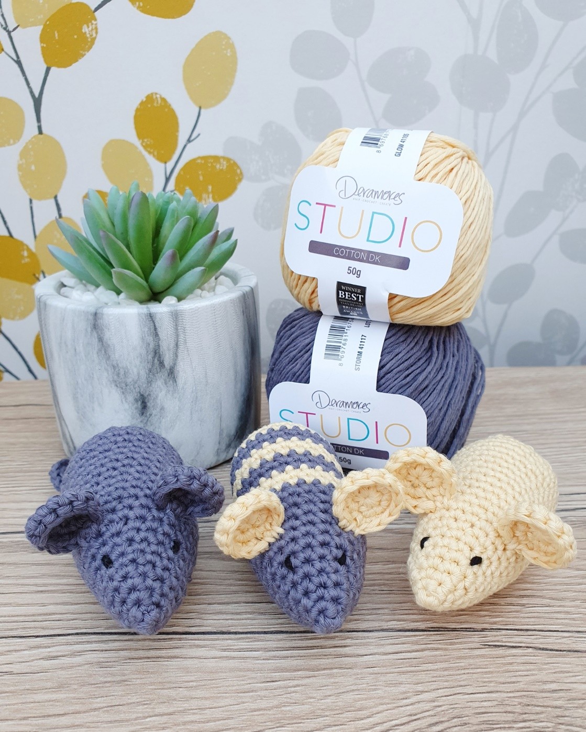

Don’t you just think these are the cutest?

What You'll Need
3mm Crochet Hook
Deramores Studio Cotton – Smoke & Glow
Deramores Studio DK - Ebony
Scissors
Stuffing
Tapestry/Wool Needle

Abbreviations

MR – Magic Ring
CH - Chain
SC – Single Crochet
INC – Increase 2 stitches in the same stitch
SS – Slip Stitch
STS – Number of stitches at the end of the round
SC2TOG – Decrease 1 stitch

Pattern

Pattern written in US Terms
Note: The pattern is worked in the round. ( ) work as many times as stated.

Solid Colour Mouse - Body

In Smoke or Glow start with a MR
Round 1: 4sc into the ring, pull tight [4 sts]
Round 2: (1sc, 1sc inc) x 2 [6 sts]
Round 3: (1sc, 1sc inc) x 3 [9 sts]
Round 4: (2sc, 1sc inc) x 3 [12 sts]
Round 5: (3sc, 1sc inc) x 3 [15 sts]
Round 6: 15sc [15 sts]
Round 7: (4sc, 1sc inc) x 3 [18 sts]
Round 8: 18sc [18 sts]
Round 9: (5sc, 1sc inc) x 3 [21 sts]
Round 10: 21 sc [21 sts]
Round 11: (6sc, 1sc inc) x 3 [24 sts]
Rounds 12 - 18: 24sc [24 sts]
Round 19: (7sc, 1sc inc) x 3 [27 sts]
Rounds 20 - 21: 27sc [27 sts]
Round 22: (7sc, 1sc2tog) x 3 [24 sts]
Round 23: (2sc, 1sc2tog) x 6 [18 sts]
Round 24: (1sc, 1sc2tog) x 6 [12 sts]
Stuff the Mouse firmly
Round 25: (1sc2tog) x 6 [6 sts]
Break yarn and sew in any loose ends.

Tail

Attach the same colour yarn you used for the body to the end of your mouse, at round 25. Ch25, ss in the 2nd chain from the hook and all the way back down your chain. SS tail to the bottom of your mouse. Break yarn and sew in any loose ends.

Ears x 2

In the same colour you used for the body start with a MR
Round 1: 6sc into the ring, pull tight [6 sts]
Round 2: (1sc inc) x 6 [12 sts]
Round 3: 12sc, ss to first sc [12 sts]
Break yarn, leaving a long tail to sew ears onto the mouse and sew in any loose ends.

Assembly

First we need to sew the ears onto the mouse. I placed my ears between rounds 9 and 10 and 4 stitches apart. Then with your ebony threaded onto your needle sew the eyes onto your mouse between rounds 5 and 6 and 5 stitches apart, mine were in line with the ears.

Break yarn and close opening sew in any loose ends.

Stripy Mouse - Body

In Smoke start with a MR
Round 1: 4sc into the ring, pull tight [4 sts]
Round 2: (1sc, 1sc inc) x 2 [6 sts]
Round 3: (1sc, 1sc inc) x 3 [9 sts]
Round 4: (2sc, 1sc inc) x 3 [12 sts]
Round 5: (3sc, 1sc inc) x 3 [15 sts]
Round 6: 15sc [15 sts]
Round 7: (4sc, 1sc inc) x 3 [18 sts]
Round 8: 18sc [18 sts]
Round 9: (5sc, 1sc inc) x 3 [21 sts]
Round 10: 21 sc [21 sts]
Round 11: (6sc, 1sc inc) x 3 [24 sts]
Round 12: 24sc [24 sts]
Change to Glow
Rounds 13 – 14: 24sc [24 sts]
Change to Smoke
Rounds 15 – 16: 24sc [24 sts]
Change to Glow
Rounds 17 – 18: 24sc [24 sts]
Change to Smoke
Round 19: (7sc, 1sc inc) x 3 [27 sts]
Round 20: 27sc [27 sts]
Change to Glow
Round 21: 27sc [27 sts]
Round 22: (7sc, 1sc2tog) x 3 [24 sts]
Change to Smoke
Round 23: (2sc, 1sc2tog) x 6 [18 sts]
Round 24: (1sc, 1sc2tog) x 6 [12 sts]
Stuff the Mouse firmly
Round 25: (1sc2tog) x 6 [6 sts]
Break yarn and sew in any loose ends.

Tail

Attach Smoke to the end of your mouse, at round 25. Ch25, ss in the 2nd chain from the hook and all the way back down your chain. SS to the bottom of your mouse. Break yarn and sew in any loose ends.

Ears x 2

In Glow start with a MR
Round 1: 6sc into the ring, pull tight [6 sts]
Round 2: (1sc inc) x 6 [12 sts]
Round 3: 12sc, ss to first sc [12 sts]
Break yarn, leaving a long tail to sew ears onto the mouse and sew in any loose ends.

Assembly

First we need to sew the ears onto the mouse. I placed my ears between rounds 9 and 10 and 4 stitches apart. Then with your ebony threaded onto your needle sew the eyes onto your mouse between rounds 5 and 6 and 5 stitches apart, mine were in line with the ears.

Break yarn and close opening sew in any loose ends.

All Finished!!!!

I really hope you enjoyed making these Super Cute Mice!!! Please take a look at my other patterns on Deramores in my designer shop!
